
a
Company
Logotype

Cone Beam Computed Tomography- Report



Porur Dental X-rays & CBCT

Patient Name : Mr. Anandaraman | Date of Report : 19.05.2024
Age/ Gender : 33 years/ Male | Region of Interest : CBCT Maxilla
Referring doctor: Dr. Rajkumar | Indication : Implant assessment
Clinical Notes: Nil
PATIENT INFORMATION

CBCT- Maxilla provided
CBCT – IMAGE DETAILS

RADIOGRAPHIC INTERPRETATION

- Presence of hyperdense restorative material within the pulp canal extending upto the apical third of the roots in relation to 16, 17.
- In 16, presence of a diffuse periapical hypodensity in relation to the mesio buccal root measuring 4.04 x 2. 54 x 2.77 mm in dimension.
- The maxillary alveolar ridge is present with normal trabecular pattern.
- Presence of mucosal thickening in relation to the floor of the right maxillary sinus is evident.

IMPLANT ASSESSMENT

 | 16 region
Sub-Crestal (in mm) | 10.46
Mid- Crestal (in mm) | 10.67
Distance between the alveolar ridge and floor of the maxillary sinus (in mm) | 4.24

RADIOGRAPHIC IMPRESSION

- Root canal treated teeth: 16, 17
- Periapical pathology in relation to 16.
- Right maxillary sinusitis.

Kindly correlate with clinical findings


IMAGES FOR REFERENCE

RECONSTRUCTED PANORAMIC VIEW

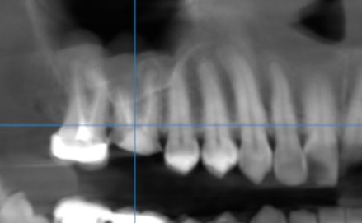

3-DIMENSIONAL VIEW

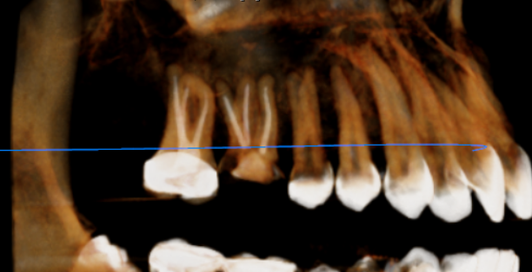

CROSS SECTIONAL VIEW

16 region | 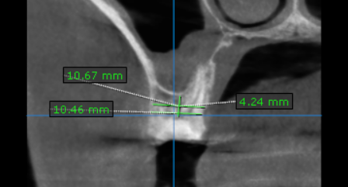

**** End of report ****

